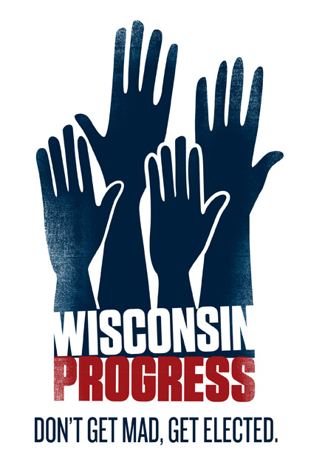
.

Wisconsin Progress Sample Campaign Plan
I. Electoral Environment & Political Landscape
Begin with short summary. What are the geography and demographics of the district? Rural, Urban, Mixed? Have there been job losses or other local factors that will play into the race? Outline the political landscape. What is the voting history of the district? What was the margin of victory in the last couple of elections?

Overall this section tells what the district is like, what has happened in the past, and how this campaign is going to win this cycle.

  - District Geography & Demographics
  - Current Political Representative and recent margins of victory
  - Key local, legislative statewide and federal races also on the ballot
  - Turnout in recent elections
  - Local Issues (if any)

This section should also include an overview of the relevant election laws. What are the contribution limits? What are the requirements to appear on the ballot?

- Targeting/Election Numbers
    - Total Expected Vote and Goal
    - Strategy for achieving win number (Persuasion vs. Increased Turnout)

- Voter Contact/Field Program
    - What is the Voter Contact Target Universe
      - Break down into how many Voters, HH, Phones this universe is for the campaign
    - ID Program
      - Prioritizing Wards & Method of Contact
        - Candidate Door Tiers
        - Volunteer Door Tiers (sometimes same as candidate)
        - Candidate Phones (if necessary) Tiers
        - Volunteer Phones Tiers
    - Volunteer Recruitment
      - Number of Volunteers Needed to Complete Field Program
      - Methods and Targets for Volunteer Recruitment
    - Create a Voter Contact Calendar

- Campaign Budget
How much money does the campaign need to raise to execute its plan? Where will you raise this money from? Most importantly, what is the campaign cash flow (when is money coming in and when is money going out?)

- Fundraising Plan
How will you raise the money you need to win?
- Call time
- Mail
- Fundraising Events

- Message
What is your campaign's general message to voters? What will your campaign say about you, what will you say about your opponent? What will your opponent say about you, what will they say about themselves? (Tully Box)

- Candidate Scheduling
How will your campaign handle candidate/campaign scheduling?

- Campaign Calendar
What are the key dates for the campaign? When can candidates file? When are the finance deadlines? What are they key events in the district that the candidate or the campaign should attend?

- GOTV Plan
  - Universe/Targets
  - GOTV Voter Contact Activities
  - GOTV Volunteer Goals
  - Create a GOTV Calendar

- Campaign Roles and Responsibilities
- Campaign Manager - paid or volunteer, there should be one person who is responsible for the day-to-day operations on the campaign.
- Finance Director - this can/should also be the same person as the campaign manager unless there is a dedicated volunteer who can take on this project. I feel strongly that if it is a volunteer position that person MUST be clear about the demands of the position and must be committed to be engaged with the campaign on a day-to-day basis.
- Field/Volunteer Coordinator: ensures that the field operation is being built through robust volunteer recruitment and execution of the field plan. I would suggest that the paid staff person work closely with the volunteer team to recruit and train volunteers for phone and canvass operations.
- New Media Director - paid or volunteer. the person who is in charge of facebook/twitter/email blasts/etc.
- Treasurer - What is the role of the treasurer on this campaign? Picking up checks? Copying checks? Depositing checks? Or just the data entry?
- Note: These may not be the roles you have on your campaign – but make sure you define which roles you need for your race, and who will fill them.

